TECHNICAL SPECIFICATIONS

(Contest Rules)

Denver Chapter Engineers Without Borders

Fourth Annual
Sand Sculpture Contest
Soda Lakes Beach
Bear Creek Lake Park
Lakewood, Colorado
August 14, 2010

2010 Version 1.0 ()

EVENT SUMMARY

What: Fourth Annual Sand Sculpture Contest

Where: Soda Lakes Beach, Bear Creek Lake Park, Lakewood

When: Saturday, August 14th, 2010

PRE-CONTEST REQUIREMENTS

Tuesday, August 3rd: Registration deadline

Wednesday, August 4th: Optional Team Captain meeting – Live Meeting/Conference Call-In at Noon for Paid-Up Teams

Saturday, August 14th: Contest date

REGISTRATION

Teams up to 10 people (minimum of 4 recommended)

Entry form can be found at the EWB website:

(www.ewbdenver.org)

Entry form and entry fee ($500 for private corporations and $150 for non-profit organizations) are due on Tuesday, August 3rd (see http://www.ewbdenver.org for additional information)

CONTEST SCHEDULE

Team check-in will occur from 7:30 am to 8:30 am

Sand sculpture construction will occur from 8:30 am to 1:00 pm

Judging will occur from 1:00 pm to about 2:00 pm

Awards will be presented immediately following the judging –

ADDITIONAL QUESTIONS

Please contact Mark Donohue (303) 842-3813 donohuema@hotmail.com for logistics questions or Jim Gusek (720) 920-4627 jgusek@golder.com with rules/technical questions.

1.0 Project Description

1.1 The EWB Sand Sculpture Contest

The Denver Chapter of Engineers Without Borders (“EWB”) has organized a sand sculpture contest.

Please join us for a day of fun, creativity, and competition during EWB-Denver’s Fourth Annual Sand Sculpture Contest. The event will be held on Saturday, August 14th, 2010 at the Soda Lakes Beach in Bear Creek Lake Park in Lakewood. Various location maps are provided below.

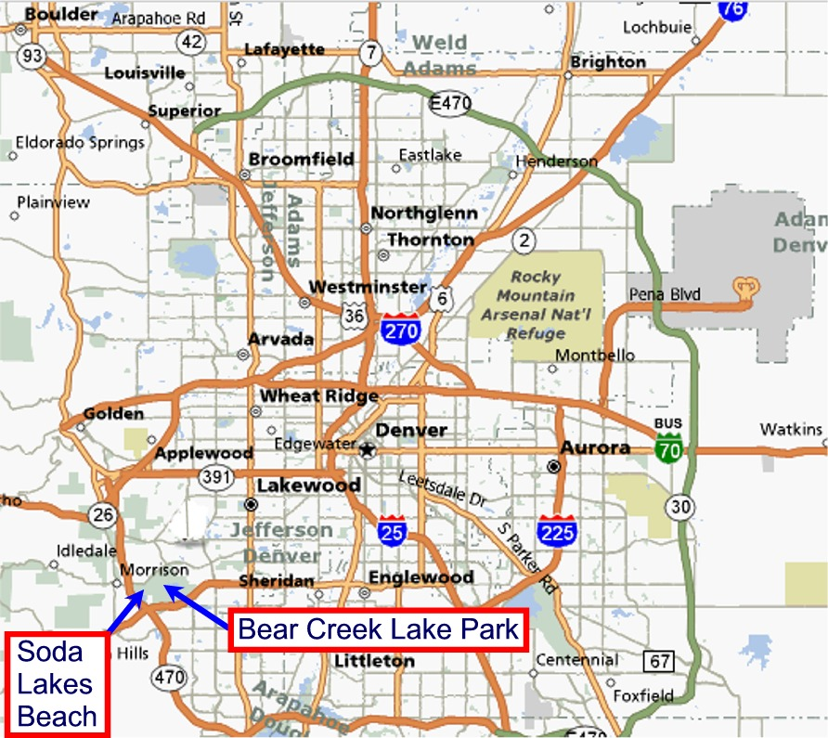

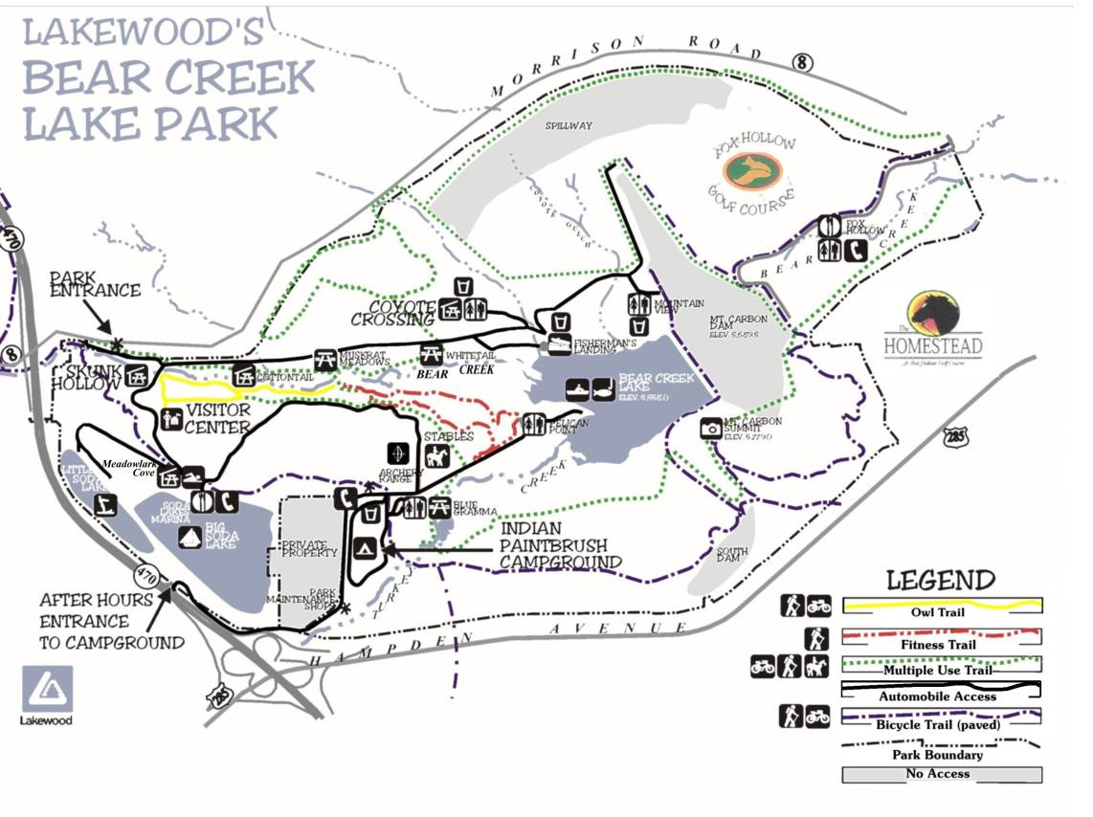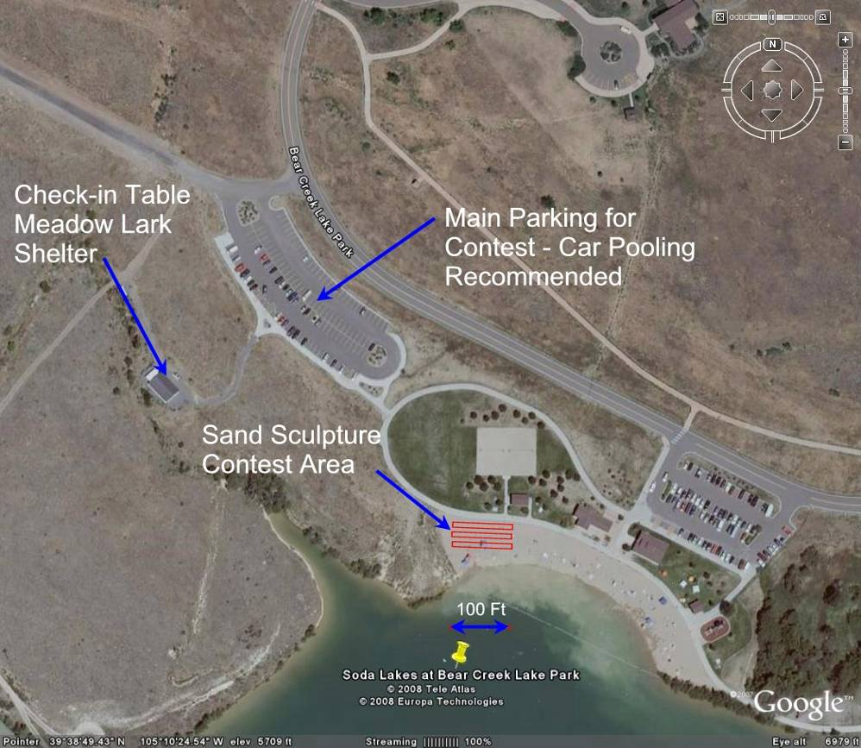
RTD Park n’ Ride
Soda Lakes Beach

Teams – of up to10 people (minimum 4 recommended but not required) will build their sand sculpture during the event. Prizes will be awarded for various categories and the sculptures constructed on the day of the event. Sand sculptures will be open for viewing with prizes awarded in the afternoon. Additional information, including the official event brochure and entry form, can be found on the following website:
www.ewbdenver.org/sand.

Additional details about Bear Creek Lake Park can be found at the following website:

http://www.lakewood.org/comres/page.cfm?ID=43&BearCreekLakePark/

2.0 Registration

2.1 Deadline

Please send check and completed entry form to:

Mark Donohue, EWB Sand Sculpture Contest
5291 Highline Place
Denver, CO 80222

Checks should be made payable to: ENGINEERS WITHOUT BORDERS-USA with Denver Chapter Sand Sculpture Contest on the comment line

Registration entry forms and entry fees must be received by Tuesday, August 3rd, 2010. Contact Mark Donohue, Event Coordinator, to request an extension.

2.2 Entry Form

Registration entry form can be found in the official event brochure, in the following website: www.ewbdenver.org/sand. A Team Captain will be identified in the entry form.

2.3 Entry Fee

a. The entry fee for a corporate team or individual is $500 (tax-deductible). The entry fee for a non-profit organization is $150 (tax-deductible). Donations above the entry fee will be gratefully accepted and may be eligible for an award.

b. Again, entry fees should be checks made payable to: “Engineers Without Border USA” with “Denver Chapter Sand Sculpture Contest” in the comment line or written somewhere on the face of the check.

c. W-9 forms documenting receipt of entry fees will be sent to Team Captains by about September 15, 2010.

2.4 Multiple Team Entries

a. Corporations, individuals, and other affiliated groups may submit up to two entries. However, these entries will be judged individually and the contest sand allotment may not be combined into a single sand structure.

2.5 Cancellation/Transfers

a. Fees with the completed entry form (see attachments) must be received by Tuesday, August 3rd, to confirm entry in the contest.

b. Late entries received after Tuesday, August 3rd, 2010 may be accepted at discretion of the Event Coordinator as long as there are no teams on the waiting list.

c. The contest is limited to the first 30 teams with paid registration. The Team Captain will be notified if a team is not one of the first 30 teams registered; the team will be placed on a waiting list.

d. If a registered team cancels, it will forfeit its entry fee and teams on the waiting list will be substituted in order.

e. EWB understands that team members may become unavailable at the last minute due to project responsibilities. Entries are fully transferable. Teams may designate that their entry be used by another group but should give EWB written notice prior to the event.

2.6 Team Member Eligibility

- Team members do not need to be employed by or affiliated with the entity entering the team.
- “Ringers” or sculpture-experienced artists who are not employed/affiliated are welcome and encouraged to join in the fun.

3.0 Pre-Contest Requirements

3.1 Optional Team Captain Meeting

a. Team Captains may wish to attend a “pre-construction” meeting at Noon on Wedensday, August 4, 2010. Invitations to this optional meeting (using the Live Meeting feature of Outlook) will be emailed captains of paid-up teams as of Tuesday, August 3rd, 2010. Rules and additional questions will be discussed during this meeting.

3.2 Activity Release

- All team members and contest participants must sign the City of Lakewood Release (attached) – no exceptions - and provide the signed copy to EWB at check-in. This is a requirement for our event permit from the City of Lakewood.

- Blank release forms will be available at the Check-In table on event day but contestants are requested to bring their signed release forms with them.

- Note there are two release forms, one for entrants over 18 and another for under 18 entrants which requires a parental or guardian signature.

4.0 Contest Requirements

Contest Location, Logistics, and Policies

- The Sand Sculpture Contest will be held at the north end of Soda Lakes Beach in Bear Creek Lake Park, Lakewood, Colorado.

- Team check-in on the day of the event shall be held at the Meadow Lark Picnic Shelter, just north of the beach; see maps in Section 1.

- Daily admission to the Park is $5 per vehicle ($4 for seniors); each team entered will receive three (3) Daily Park Passes in advance when EWB-Denver receives the team’s entry fees.

- Carpooling is encouraged; there is an RTD Park and Ride parking lot off the C-470 exit to Morrison Road. See map on page 4.

- If contestants wish to enter the park in more than three vehicles, the extra daily park fees are their own responsibility.

- Parking spaces are limited; the paved parking lot adjacent to the Meadow Lark Picnic Shelter has been reserved for contestants. If additional parking is necessary, signs and/or EWB-personnel will direct overflow traffic.

- Contestants are requested not to park in the lots immediately adjacent to the beach or the boat ramp.

- Glass containers are not allowed anywhere in the park.

Schedule

a. The Sand Sculpture Contest will be held on Saturday, August 14, 2010.

b. The check-in table will be open from 7:30 am to 8:30 am.

c. Sand structure construction may commence immediately after a team checks in but shall conclude before 1:00 pm.

d. Judging will begin promptly at 1:00 pm.

e. The awards ceremony will be held as soon as possible at the conclusion of the judging. The awards ceremony will be held on the beach or near it.

4.3 Sculpture Space

a. Each team will be allocated a working space that is a minimum of 10 feet by 15 feet.

4.4 Water
a. Teams may use water from Soda Lake for sand sculptures. The team should be prepared to transport the water from the lake shore to their sand allotment/contest entry area. The shore is about 100 feet from the contest area.

4.5 Tools

a. Each team will be provided with two (2) five-gallon plastic buckets for its use. These become the team’s property and they may be taken home. Unwanted buckets should be returned to the check-in table.

b. Each team will provide its own tools. Tools may not be motorized or battery powered. Many websites and books provide useful tool lists for sand sculpting; teams are encouraged to be innovative.

c. Teams are encouraged, but not required, to use molds. Molds can be used to create complex shapes, facilitate compaction, and generally save time. For example, an ice cube tray can be used to quickly recreate the crenulations on the top of sand castle walls.

4.6 Sculpture Accessories

a. Each team is not required but may use up to one pound (454 grams) of sculpture “accessories” to enhance its sculpture. These may include flags, banners, scale vegetation, castle armaments, etc.

b. Sculpture accessories may be prepared by the team in advance of the contest.

c. Such accessories must be comprised of natural materials such as plant stems, flower petals, tree bark, grass/straw, tree branches, hair, etc. If glue is used to assemble the accessories, it may be man-made.

4.7 Team Banner and Entry Explanation Sheet

a. Each team may erect a team banner at the rear of its allocated space that identifies their organization. The team must remove the banner at the end of the contest.

- Each team shall provide an explanation sheet no larger than 11 inches by 17 inches, optionally mounted on cardboard, which provides background information on their entry. The sheet may include a design sketch, what the entry is about, or other pertinent information. The sheet content will not be judged but the complete lack of the sheet will result in five (5) lost points in judging the entry.

4.8 Sculpture Protection

a. Each team will be responsible for preserving their sculpture until it is judged. This may involve applying a water mist to preserve the moisture conditions of the sculpture surface.

4.9 Sculpture Demolition

- Teams are requested to remove any sculpture accessories at the conclusion of the judging. This may be waived on request from the team or EWB Denver.

- Sand sculptures will be demolished at a later date by EWB or the City of Lakewood; teams are requested to leave their sculpture for other park visitors to enjoy for the rest of the day.

5.0 Sand Specification

5.1 Quantity
a. Each team will be provided with about three (3) loose cubic yards of sand.

- Each team will be provided with an area of about 150 feet (10 x 15). The team will construct its sculpture within the confines of the area. Common aisles between teams will be developed in the field depending on the number of teams entered.

5.2 Sand Characteristics

- The sand to be used in the contest may meet the following approximate gradation. At this time, the exact grain size distribution of the sand is unknown but it may be a mixture of “mortar sand” meeting the gradation shown below and “concrete sand” which may have a slightly higher top size.

Sieve % Passing
4 (4.75mm) 100
8 (2.36 mm) 95-100
16 (1.18 mm) 70-100
30 (0.60 mm) 40-75
50 (0.30 mm) 10-35
100 (0.15 mm) 2-15
200 (0.075 mm) 0

- It is important to note the virtual lack of minus 200 mesh material present in the sand. It has limited cohesion-based strength and may require interior reinforcement (see Section 4.6, Accessories) to withstand static loads inherent in taller sculptures.

- In Layman’s terms – don’t try to sculpt a tall, thin entry with steep sides without giving your design a lot of thought; it will likely collapse under its own weight before you finish it.

- The moisture content of the sand on contest day is unknown and may not be optimal for sculpting.

- The foundation soils on the beach have not been geotechnically investigated. However, based on previous experience, this soil may have a significant amount of minus 200 mesh material present and teams are allowed to exploit this situation in any way within the rules. For example, this foundation material might be used to create a high-moisture content “paste” that may be applied in any number of creative situations.

- The sand currently present on the Soda Lakes Beach is more representative of the sand that EWB will provide to the teams. Visit the site on your own & take a dip in the lake.

6.0 Judging & Awards

a. Sand sculpture judging will begin at 1:00 pm. Awards will be presented as soon as possible after the judging forms are tallied.

- Sand sculptures will be judged by an independent panel of up to three judges.

- Sand sculptures will be judged based on the following criteria:

Judging Criteria | Maximum Points | Comments
Relative Height | 5 | How tall is the sculpture compared to its neighbors and other entries?
Realism | 10 | Can you tell what it is? Attention to scale consistency throughout if it’s a structure
Attention to Detail & Use of Accessories | 10 | Abundance and care applying surface textures and building complicated design elements. Accessories can significantly enhance the overall appearance of the sculpture. How effectively does the team use its one pound allowance?
Structural Engineering | 10 | How’d they do that? – inclusion of arches, flying buttresses, cantilevered elements, vertical walls, overhangs, etc.
Explanation Sheet (required) | 5 | Teams communicate information about their sculpture, perhaps something about the creative process or history of their subject. See Section 4.7.B
“Wow” Factor | 10 | These are discretionary points available for each judge to express his/her overall impression of the sculpture with all the design and execution elements combined into a single number.
Total | 50

e. There will be two main “technical” judging categories:

- Engineered Structure (real or imagined subject) – this can be a building, castle, bridge, or other man-designed and constructed facility.

- Open Sculpture (real or imagined object) – this “open” category is up to the team’s imagination, sand sculpting skills, and the geotechnical characteristics of the sand.

- A “Fundraising Favorite” award may be granted to the team who raised the most money, either by sending in more than the required entry fee, or soliciting independent donations to EWB Denver prior to or on the day of the event.

- An award will be granted to the team whose sculpture is deemed “The Kid’s Choice”. On request, park visitors (children under 12) will be each issued a single vote slip/ballot to vote for their favorite. Donated money does NOT count toward the Kid’s Choice award tally (see Fundraising Favorite above) even though the votes and donations might be placed in the same ballot box provided by EWB Denver.

- EWB may elect to provide free “Kid’s Choice” awards ballots to seniors not associated with the contest.

ATTACHMENTS

Judging Form

City of Lakewood Activity Releases
Denver Chapter Engineers Without Borders
Sand Sculpture Contest Judging Form
Soda Lakes Beach, Bear Creek Lake Park – August 14th, 2010

Judge________________________________________________

Entry Name/No. __________________________________________

Description of Entry ___________________________________________________

Judging Category (Check one)

□ Structure (castle/building, etc.)

□ Open Sculpture (anything goes)

Scoring

1. Relative Height (to top of sand) 1 -5 Score_________
2. Realism (You can tell what it is-life size?) 1 -10 Score_________
3. Attention to Detail & Use of Accessories 1 -10 Score_________
4. Structural Engineering (how’d they do that? -
arches, flying buttresses, cantilevered elements) 1 -10 Score_________
5. Entry Explanation Sign (11 x 17) Zero or 5 Score_________
6. Wow Factor (discretionary points) 1 -10 Score_________

TOTAL SCORE out of 50 ____________

(Judges: EWB Denver volunteers will do the addition on request)
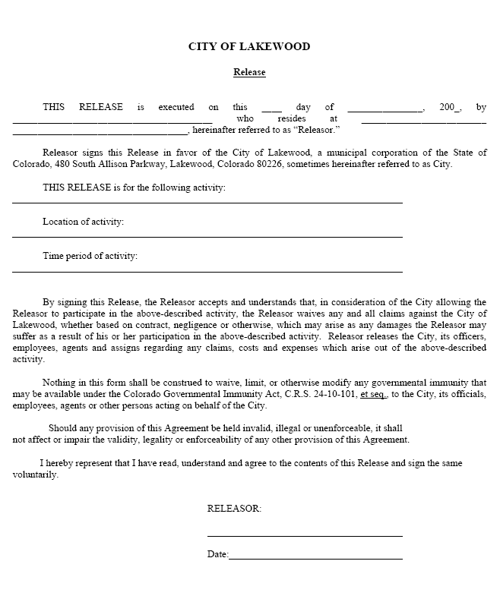
7:30 am to 3:00 pm
Soda Lakes Beach, Bear Creek Lake Park
Denver Chapter Engineers Without Borders Sand Sculpture Contest
August
9
14th

